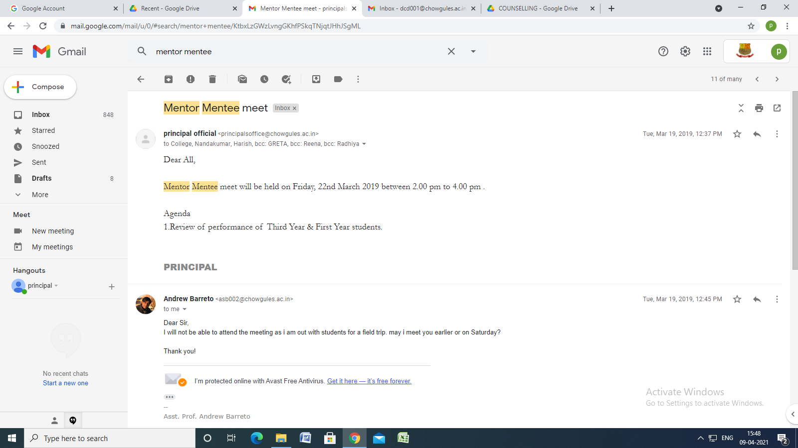

Mentor Mentee meet
Inbox
principal official <principalsoffice@chowgules.ac.in> | Mar 19, 2019, 12:37 PM
to College, Nandakumar, Harish, bcc: GRETA, bcc: Reena, bcc: Radhiya

Dear All,

Mentor Mentee meet will be held on Friday, 22nd March 2019 between 2.00 pm to 4.00 pm .

Agenda
1.Review of performance of Third Year & First Year students.

PRINCIPAL

